- [5 points] A room is heated is a 1500 W electric heater.
- How much power would be saved if we replace the heater with a heat pump with a COP of 2.0?
- If the heating is required 25% of the time in a given year and the heat pump costs $10000, what is the payback period for the heat pump if the cost of electricity is $0.20 per kW-hour (Note this is the cost to purchase 1kW of electricity for one hour).
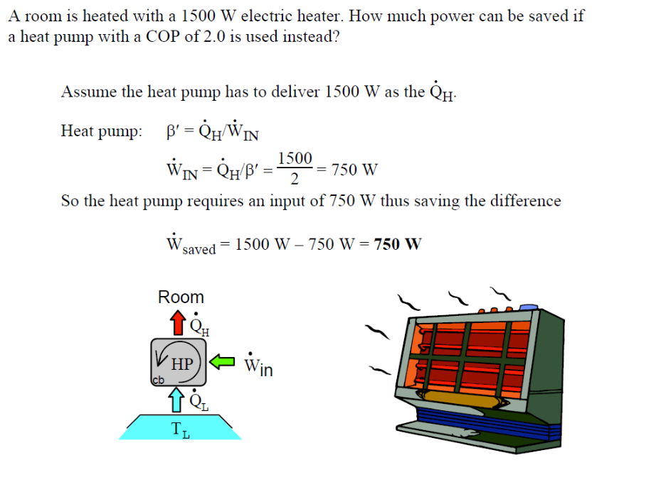
Payback period = (capital cost) / (cost saved per hour).
Cost saved = $0.2 *(0.75 kW)*(25% operating time) = $0.0375 per hour
Payback = $10000/.0375 = 266666 hours or ~30 years. At this rate of payback it would not be recommended unless the cost of electricity was much higher.
2. [5 points] A power plant uses the ambient air at 20 C as the low temperature reservoir and 800C as the high temperature reservoir.
a) what is the maximum thermal efficiency.
c) If the specific power rejected to the environment is 1000 kJ/kg, what is the heat the must be supplied during the heat addition phase?
b) If the efficiency of a Heat Engine increases as we decrease the low temperature reservoir’s temperature, why not use a refrigerator to generate a cold temperature reservoir at -10C.
- Use carot efficiency n = 1 – Tl /Th
- Qh/Ql = Th/Tl so Qh = Th/Tl * Ql
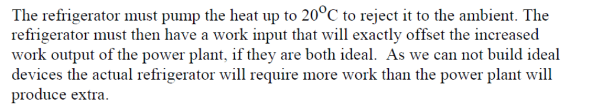

3. [5 points] A power plant uses a heat engine to produce electricitiy. In the cycle 1MW of heat is added in the heat addition phase, 0.02MW of power is used in the pump, and 0.58MW of power is taken out in the heat rejection process to the environment.
a) What is the power produced in the turbine which is generating the electricity?
b) What is the net power provided to the grid?
c) what is the heat engine efficiency for this system?
d) If the fuel combustion temperature is 800 C and the environmental temperature is 20 C, does this cycle satisfy the Carnot Principles?
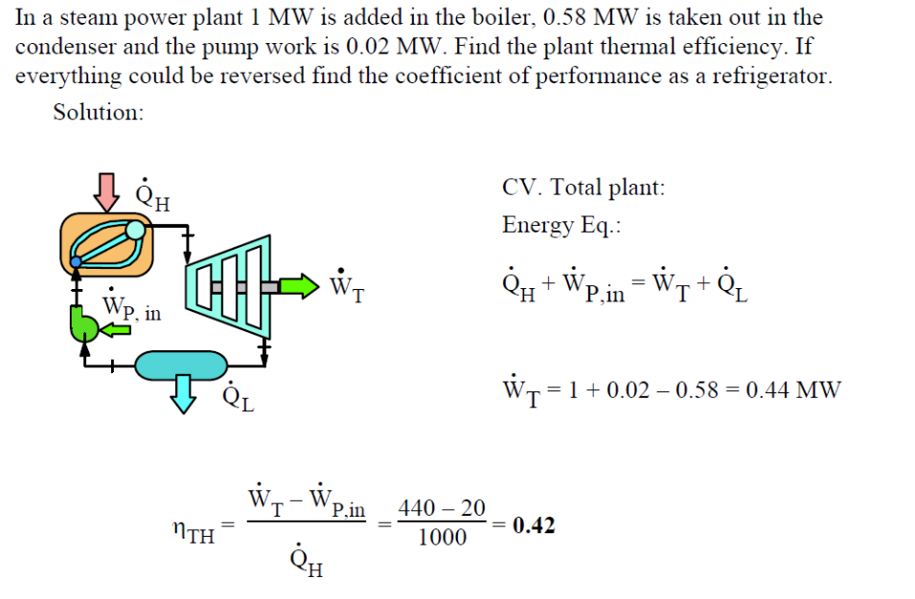
Net work is Wt - Wp
- Yes since a carnot engine operating between Th and Tl has a higher efficiency than the real engine
